1. Design the below page using HTML. Write only HTML.

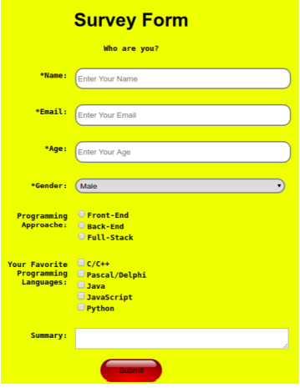

1. Create the below page using HTML. Write the JAVA SCRIPT code to validate the user input on clicking the SUBMIT button as follows

a. None of the input fields are empty

b. Message field must not be more than 140 characters long. If all validations are passed alert a message “VALIDATION SUCCESSFUL

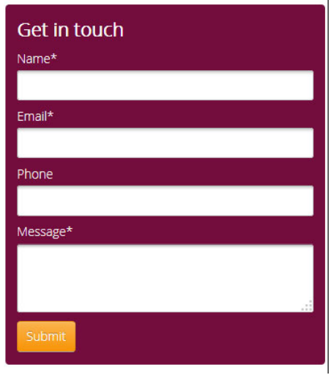

1. Create a html page mentioned as follows. Create this page using tables only. Use internal CSS only to apply the shown styles to the data and cells.

Change text color: red and italic

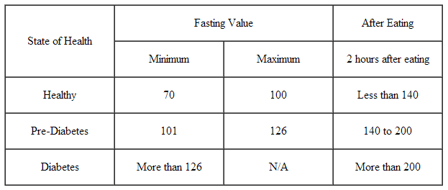

1. Design the below page using HTML. Write only HTML. . (10)

a.HTML

b.JS

c.AJAX

d.PHP

I. Java Script

II.XML

* HTML
* JS
* AJAX
* PHP

1. HTML
2. JS
3. AJAX
4. PHP

(5) Create the below page using HTML. Write the JAVA SCRIPT code to validate the user

input on clicking the button as follows

1. Onclicking First button, the text present in the Text field should changed as red colour and text background as pink color, Uppercase.
2. Onclicking First button, the text present in the Text field should changed as yellow colour and text background as red color, Uppercase

6. Create a html page mentioned as follows. Create this page using tables only. Use internal CSS only to apply the shown styles to the data and cells.

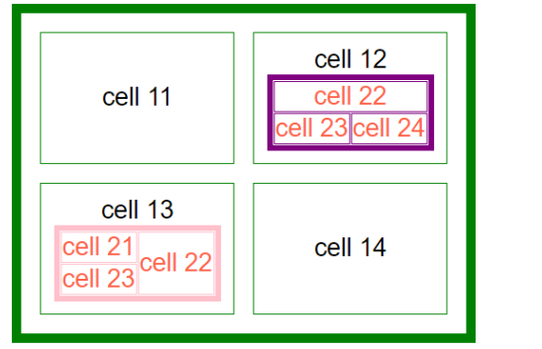

7. 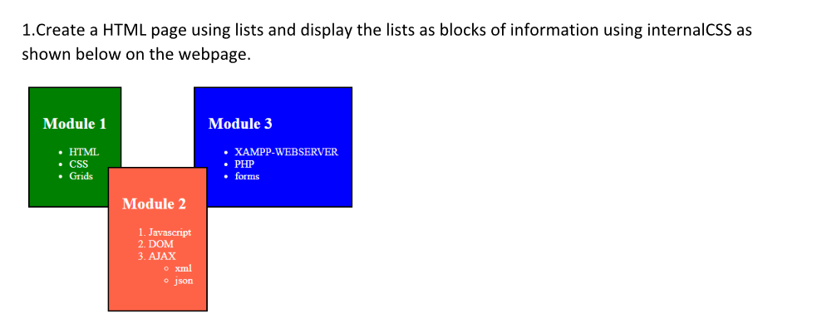

8. Create a webpage using PHP that consists of textboxes to read “empid,” “salary,” “eName,” and “address.” The webpage should consist of submit and reset buttons. The form should be directed to a php file to

1. Check whether empid is proper or not (length of empid must be 8, the first four places of empid must be characters and the remaining are digits)
2. Salary must contain digits only and number of digits should be in the range (4-6).
3. eName must have characters only. The first character has to be capital letter.
4. Display the length of the address on the webpage.

9. Create a PHP script to read the data from a text file, “company.txt” consisting of various company names. Count the number of companies and display them as a list in the following way.

If company.txt contains “abc aab aac bbc bba bbt cca ccn cnn”. The webpage should display the list as,0

Count of companies:9

* aab, aac, abc
* bba, bbc, bbt
* cca, ccn, cnn

10. Consider a table “Compinfo” with fields (Compname(string), product(int), price(int), address(string)) in “compdb” database in MySQL.

a. Create home.php page consisting of hyperlinks for about.php, create.php, remove.php pages.

b. The create.php page helps to insert a new record into the table and has four textboxes and a submit button.

c.The about.php lists all the company names in the database

d. Develop remove.php page to remove a record based on the compname and address

11. Create a webpage using PHP that consists offour textboxes with labels “number1,” “number2,” “Name,” and “address.” The webpage should consist of submit and reset buttons. The form should be directed to a php file to

1. Display the sum of digits of number1.
2. Display the number2 in reverse order.
3. Converts the name into upper case and also displays it as a heading of the page.
4. Display the length of the address on the webpage.

12. Create a PHP script to read the data from a text file, data.txt. Count the number of characters in the text file and display them on the web page. Write all the words which starts with a uppercase character of data.txt file into uppercase.txt file.

13. Develop an application involving PHP and MYSQL as follows.

Consider a table “userinfo” with fields (username, password, country, contact) in “userdb” database of MySQL.

1. Create home.php page consisting of hyperlinks for about.php, login.php, change.phppages.
2. The about.php should display the names of all users in the database.
3. The login page has two textboxes username and password and submit button. On clicking the submit button the user has to be validated based on the data stored in the table.
4. The change.php page has three textboxes, username, old password, new password and allows the user to change/update the password once the user enters username old password correctly, otherwise displays “incorrect details”.

14. Use AngularJS to create two controllers favsubject and favmovie consisting of subnames, movnames arrays respectively.

Create two textboxes FavouriteSubject and FavouriteMovie and respective buttons to add favourite subjects and movies to respective arrays.

Also create 2 buttons to remove the last items of each array. Use appropriate directives of angularJS to display the list of arrays on the webpage.

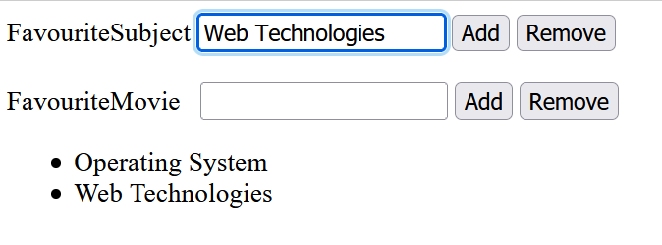

15. Angular JS with MySQL Database connectivity.

16. HTML Form design with JavaScript to validate the form